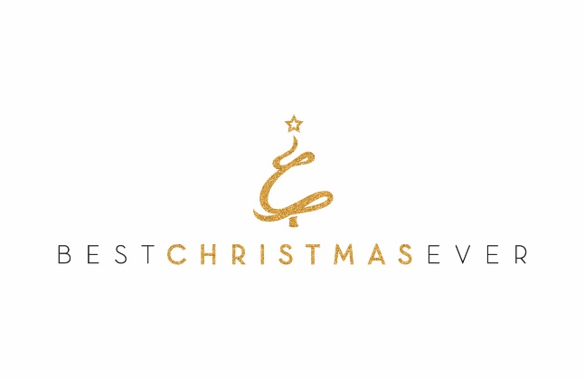
September 30, 2020

Wright Hennepin Electric Trust
Post Office Box 330
Rockford, MN 55373

Dear Members of the Grant Review Committee,

Thank you for your consideration of Best Christmas Ever’s (BCE) proposal for program funding. We respectfully request a $2,000 grant to help support our life-changing programs.

Since 2011, BCE has been bringing generosity and hope to Minnesota families. Our founder was surprised with unexpected gifts and kindness on Christmas Eve 2010 and has since paid it forward by establishing an organization that has served 451 families (1,804 individuals) and distributed over $4,000,000 in program goods and services.
BCE families don’t just receive wrapped gifts. Nominations come from close families and friends so we can personalize the BCE experience with gifts and support that will impact their lives for the long term. We have helped pay mortgages, update a furnace, buy cars, and even pay for a medical dog. We also provide wraparound financial literacy and wellness programs, help pay down debt, and provide basic needs food support through grocery store gift cards.
The requested grant will help fund the 2020 Christmas season and the programs that are provided as follow-up including health and wellness and financial education. BCE will impact 150 families (600 individuals) this year.
Thank you for your review of this proposal. If you have any questions or need more information, please call me at (218) 499-1342 or email don@donliimatainen.com.

Regards,

Don Liimatainen
President & CEO

