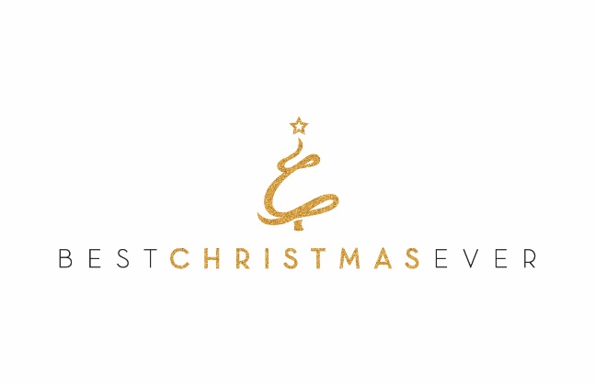
Engelsma Family Foundation Board

Dear Sir or Madam,

Best Christmas Ever (BCE) is pleased to introduce ourselves to The Engelsma Family Foundation Board for your review in grant approval. Best Christmas Ever is a 501(c)3 nonprofit with the mission of providing a family who has fallen on tough times, through no-fault of their own, with a life-altering “Best Christmas Ever”.
The idea of the “Best Christmas Ever” originated when our founder battled Ulcerative Colitis at Christmas time. During his lowest moment, he was surprised with two full bags of gifts on Christmas Eve of 2010, turning what would have been his worst Christmas ever into the ‘Best Christmas Ever’! Wanting to pay it forward; in 2011, he and his lifelong friend rallied a small group of friends and family together to surprise one family in their community with the Best Christmas Ever, just as he had received! From that seed God planted, a vision was created to increase the number of families surprised each year. This year, many families throughout the United States and Canada will receive the Best Christmas Ever, bringing hope, joy, peace, and a life-lasting change.
A Best Christmas Ever family is nominated by community members (friends, extended family, co-workers, etc.). Our Volunteer Captains and their team works with the family’s nominator and raises funds for the family, along with gifts for each family member. During the week leading up to Christmas, the nominator and the BCE Team SURPRISES the BCE family by arriving at their doorstep with the with these gifts to provide the Best Christmas Ever! Additionally, each family who receives a Best Christmas Ever has the opportunity to participate in a Dave Ramsey’s Financial Peace University (FPU) and a Total Wellness Health Program. Upon completion of FPU, a $1,000 grant is gifted to the BCE family to pay off a debt. In addition, $1,000 in gift cards to an approved grocery store is granted to the BCE family for completion of the Total Wellness Health Program.
BCE’s Vision: “Bringing hope to families through committed volunteers acting with bold generosity to positively impact generations in communities throughout the world”.

Thank you for your consideration,

Best Christmas Ever

